**Minesweeper - System Architecture Document**

Team 28

The University of Kansas

EECS 581 - Software Engineering II

**Nabeel Ahmad, Aniketh Aatipamula, Omar Mohammed,**

**Shero Baig, Humza Qureshi, Yaeesh Mukadam**

**Document Revision History**

|  |  |  |  |
| --- | --- | --- | --- |
| **Date** | **Version** | **Comment** | **Author** |
| 08/26/2025 | 1.0 | File is created, Outline is built for readability and future additions/revisions, | Nabeel Ahmad |
| 09/04/2025 | 1.1 | Added relevant information for Board Structure | Nabeel Ahmad |
| 09/14/2025 | 1.2 | Complete Components, Update Table of Contents, | Nabeel Ahmad, Omar Mohammed |
| 09/19/2025 | 1.3 | Add Relevant Diagrams, Complete Data  Flow, Complete Key Data Structures,  Complete Assumptions | Nabeel Ahmad, Omar Mohammed |
| 09/23/2025 | 1.4 | Fixing some wording/directions, formatting | Reeny Huang |

Table of Contents

**Section 1 – Purpose 4**

**Section 2 – Components 4**

2.1 Board Manager 4

2.2 Game Logic 4

2.3 User Interface (UI) 4

2.4 Input Handler 5

**Section 3 – Data Flow 6**

3.1 User Input → Input Handler → Game Logic 6

3.2 Game Logic → Board Manager 6

3.3 Board Manager → User Interface 6

**Section 4 – Key Data Structures 7**

4.1 Cell 7

4.2 Board 7

4.3 GameState 8

**Section 5 – Assumptions 9**

5.1 Game Setup 9

5.2 Gameplay 9

5.3 Mine Flagging 9

5.4 Player Interface 9

5.5 Game Conclusion 9

**Section 6 – Person-Hours Estimation 10**

6.1 Estimation Methodology 10

6.2 Person-Hours Estimate Table 10

**Section 7 – Actual Person-Hours Accounting 10**

7.1 Actual Person-Hours Table 10

# Section 1 - Purpose

The purpose of this project is to develop a single-player puzzle game known as Minesweeper. The grid (10 x 10) has columns labeled A-J and rows numbered 1-10. The game consists of a grid with a mine count (10-20) chosen by player. Players uncover a cell by left clicking on the cell. When a player uncovers a mine, the game ends. Otherwise, uncovering a safe cell reveals a number from 0-8 indicating adjacent mines. Cells with zero adjacent mines trigger recursive uncovering of adjacent cells. Players can right click a cell to toggle flags on covered cells to mark suspected mines. We implement the game in the browser using a Next.js framework utilizing TypeScript and CSS. This allows for simpler Graphical User Interface (GUI) operability for the user and enables portability across various platforms.

# Section 2 - Components

## 2.1 Board Manager

## This component manages the 10 x 10 grid and tracks cell states. Cell states can either be covered, flagged, uncovered, or mine.

## Key responsibilities:

## Manage grid (10 x 10)

## Track each cell state for:

## Covered (hidden, default state)

## Flagged (player suspects a mine)

## Uncovered (revealed, safe cell)

## Mine (dangerous cell)

## 2.2 Game Logic

This component enforces Minesweeper rules. It processes uncovering, flagging, and recursive revealing of adjacent zero-valued cells. It detects game-ending conditions (loss when a mine is uncovered, victory when all safe cells are revealed) and communicates the updated status to the User Interface. Upon board initialization, the Game Logic component guarantees the first-clicked cell is mine free.

Key responsibilities:

## Validate moves (ignore flagged cells)

## Count adjacent mines (0-8) for each revealed cell

## Handle recursive flood-reveal when zero mines are adjacent

## Trigger “reveal all mines” on loss

## Track win/loss status

## Guarantee first-clicked cell is mine free

### 2.3 User Interface (UI)

The UI presents the game state visually to the player inside a web browser. It renders the 10x10 grid with column labels (A-J) and row labels (1-10), shows flagged, uncovered, and covered cells, and displays the remaining mine count and current game status (“You Win” or “You Lost”).

Key responsibilities:

## Provide intuitive controls for uncovering and flagging cells

## Display accurate cell contents (number, blank, mine, flag)

## Update dynamically in response to Board Manager and Game Logic state changes

## 2.4 Input Handler

The Input Handler captures and interprets user actions such as left-click (uncover cell) and right-click (toggle flag). It validates these inputs (ex. preventing uncovering a flagged cell) and forwards them to the Game Logic. It also handles optional keyboard shortcuts if implemented.

Key responsibilities:

## Translate raw user interactions into structured commands

## Prevent invalid moves

## Provide consistent communication between UI and Game Logic

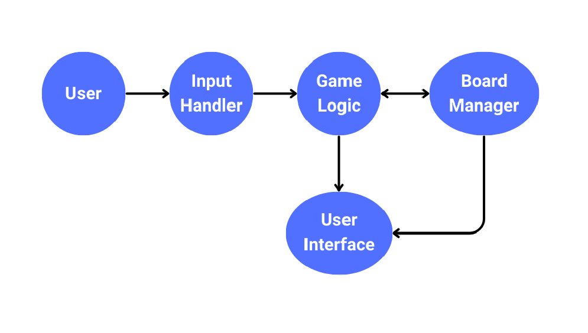

Figure 1: Component Interaction Pathway

# Section 3 - Data Flow

## 3.1 User Input → Input Handler → Game Logic

User Input (ex. clicking a cell) is first captured by the Input Handler. The Input Handler translates the actions by the user into commands that can be processed by the system. If an invalid command is generated, the handler will ignore the input, otherwise valid commands are to be passed to Game Logic. The Game Logic Component will interpret the input given the context of the current state of play (ex. cell uncovering or flag toggling).

## 3.2 Game Logic → Board Manager

Once the Game Logic interprets a valid user action, board update requests are sent to the Board

Manager. The Board Manager is utilized in areas where the state of the grid needs to be adjusted. This includes whether a cell is covered, flagged, or contains a mine. Game Logic works to delegate grid manipulation to the Board Manager. Game Logic maintains the rules of the game while the Board Manager maintains the underlying data.

## 3.3 Board Manager → User Interface

The Board Manager supplies the User Interface with the current state of the board. The User Interface requests the necessary details from the Board Manager (ex. cell is hidden, flagged, or uncovered). With incoming data from the Board Manager, the User Interface ensures the user views the board in the most current and relevant state.

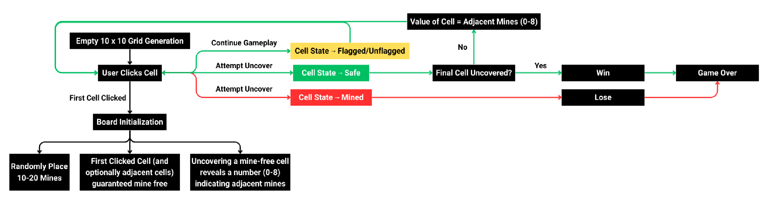

Figure 2: Data Flow Chart

# Section 4 - Key Data Structures

## 4.1 Cell

## Purpose: Unit of game state stored in the board

## Fields (as used across UI/Logic):

## 𝑖𝑠𝑀𝑖𝑛𝑒: 𝑏𝑜𝑜𝑙𝑒𝑎𝑛 → whether the square holds a mine

## 𝑟𝑒𝑣𝑒𝑎𝑙𝑒𝑑: 𝑏𝑜𝑜𝑙𝑒𝑎𝑛 → whether the square is uncovered

## 𝑓𝑙𝑎𝑔𝑔𝑒𝑑: 𝑏𝑜𝑜𝑙𝑒𝑎𝑛 → whether the player marked a flag

## 𝑎𝑑𝑗𝑎𝑐𝑒𝑛𝑡: 𝑛𝑢𝑚𝑏𝑒𝑟 → count of adjacent mines (0-8)

## 4.2 Board

## Purpose: Authoritative grid of cells and basis for adjacent queries

## Shape: 𝐶𝑒𝑙𝑙[][] 10 × 10 → where this is a grid in current configuration

## Provided/used operations:

## 𝑐𝑟𝑒𝑎𝑡𝑒𝐸𝑚𝑝𝑡𝑦𝐵𝑜𝑎𝑟𝑑(𝑟𝑜𝑤𝑠, 𝑐𝑜𝑙𝑠) → initialize cells

## 𝑝𝑙𝑎𝑐𝑒𝑀𝑖𝑛𝑒𝑠(𝑏𝑜𝑎𝑟𝑑, 𝑚𝑖𝑛𝑒𝐶𝑜𝑢𝑛𝑡, 𝑠𝑎fe𝐴𝑡?: 𝑃𝑜𝑠𝑖𝑡𝑖𝑜𝑛) → populate mines (first-click safe)

## 𝑐𝑜𝑚𝑝𝑢𝑡𝑒𝐴𝑑𝑗𝑎𝑐𝑒𝑛𝑐𝑦(𝑏𝑜𝑎𝑟𝑑) → compute adjacent counts

## 𝑐𝑙𝑜𝑛𝑒𝐵𝑜𝑎𝑟𝑑(𝑏𝑜𝑎𝑟𝑑) → immutable-style updates for React state

## 𝑓𝑙𝑜𝑜𝑑𝐹𝑖𝑙𝑙(𝑏𝑜𝑎𝑟𝑑, 𝑔𝑟𝑖𝑑𝑆𝑖𝑧𝑒, 𝑟, 𝑐) → zero-expansion reveal

## 4.3 GameState

## Purpose: High-level session state owned by page controller

## Fields:

## 𝑚𝑖𝑛𝑒𝑠: 𝑛𝑢𝑚𝑏𝑒𝑟 → total number of mines placed at the start of the game

## 𝑏𝑜𝑎𝑟𝑑: 𝐶𝑒𝑙𝑙 [][] → 2D array holding all cell objects (the board state)

## 𝑠𝑡𝑎𝑟𝑡𝑒𝑑: 𝑏𝑜𝑜𝑙𝑒𝑎𝑛 → True once the first reveal is made (used for timing and first-click safe logic

## 𝑔𝑎𝑚𝑒𝑂𝑣𝑒𝑟: 𝑛𝑢𝑙𝑙 | '𝑙𝑜𝑠𝑡' | '𝑤𝑜𝑛'

## 𝑛𝑢𝑙𝑙 → game continues

## '𝑙𝑜𝑠𝑡' → player reveals a mine

## '𝑤𝑜𝑛' → all non-mined cells uncovered

## 𝑓𝑙𝑎𝑔𝑠𝐿𝑒𝑓𝑡: 𝑛𝑢𝑚𝑏𝑒𝑟 → number of flags still available for the player

## 𝑠𝑒𝑐𝑜𝑛𝑑𝑠: 𝑛𝑢𝑚𝑏𝑒𝑟 → elapsed gameplay time in seconds

○ 𝑠𝑒𝑐𝑜𝑛𝑑𝑠: 𝑛𝑢𝑚𝑏𝑒𝑟 → elapsed gameplay time in seconds

Figure 3: Unified Modeling Language (UML) Diagram for Key Data Structures

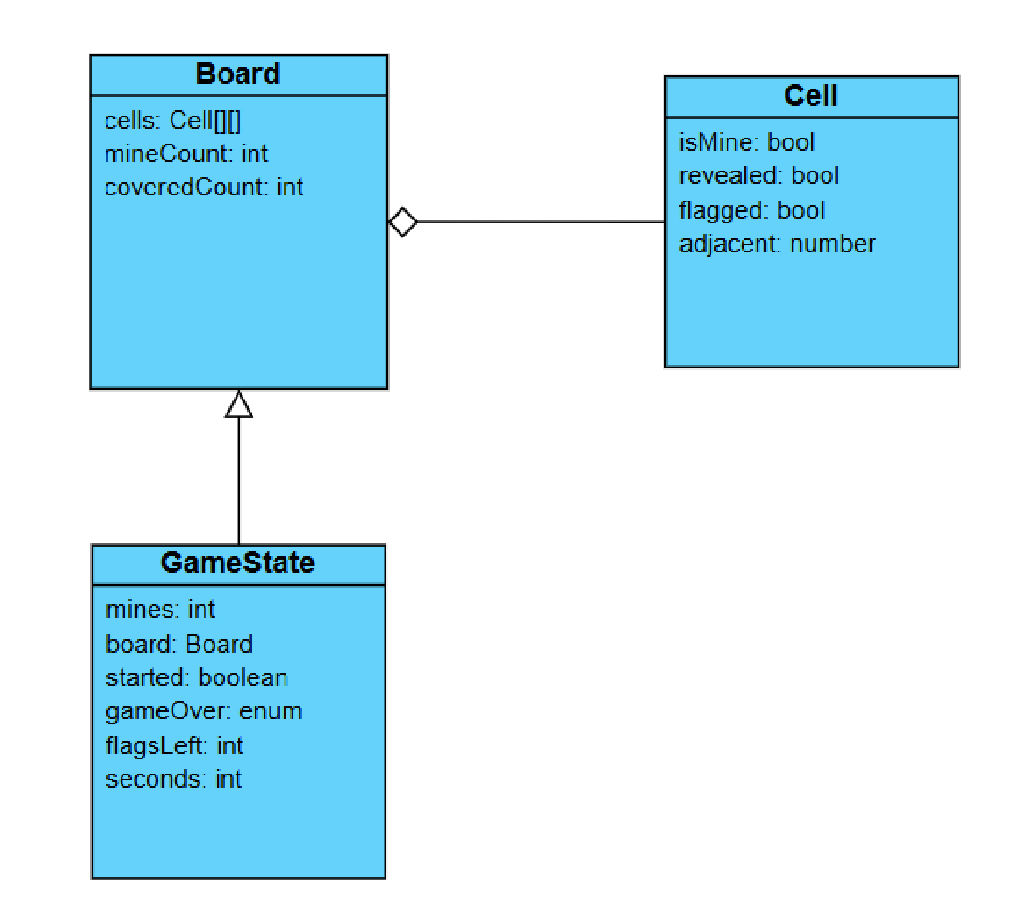

# Section 5 - Assumptions

## 5.1 Game Setup

## Fixed 10 x 10 grid size

## Columns labeled A-J

## Rows numbered 1-10

## Number of Mines: User specified: 10-20

## Randomly placed at game start

## First clicked cell (and optionally adjacent cells) guaranteed mine-free

## Initial State: All cells start covered with no flags

## 5.2 Gameplay

## Players uncover a cell by selecting it (clicking)

## Uncovering a mine ends the game in a loss

## Uncovering a mine-free cell reveals a number (0-8) indicating adjacent mines

## Cells with zero adjacent mines trigger recursive uncovering of adjacent cells

## Players can toggle flags on covered cells to mark suspected mines

## 5.3 Mine Flagging

## Players place/remove flags on covered cells to indicate potential mines

## Flagged cells cannot be uncovered until unflagged

## Display remaining flag count (𝑡𝑜𝑡𝑎𝑙 𝑚𝑖𝑛𝑒𝑠 − 𝑝𝑙𝑎𝑐𝑒𝑑 𝑓𝑙𝑎𝑔𝑠)

## 5.4 Player Interface

## Display a 10 x 10 grid showing cell states:

## covered

## flagged

## uncovered (number or empty for zero adjacent mines)

## Show remaining mine count (𝑡𝑜𝑡𝑎𝑙 𝑚𝑖𝑛𝑒𝑠 − 𝑡𝑜𝑡𝑎𝑙 𝑓𝑙𝑎𝑔𝑠)

## Provide a status indicator for gameplay

## 5.5 Game Conclusion

## Loss: Triggered by uncovering a mine, revealing all mines

## Win: Achieved by uncovering all non-mine cells without detonating any mines

# Section 6 - Person-Hours Estimation

## 6.1 Estimation Methodology

For the person-hours estimate, a structured approach was used to evaluate a probable length of time for determining task completion. This structure relied on experience in previous software engineering projects, ranging from real-world applications to school applications. This was especially useful for areas related to team member contributions and dynamics. For each task, time estimates were derived using references from previous projects allowing for realistic estimations. For areas where historical reference was not applicable, a consensus-based method was used to provide informed estimates. For project uncertainties and external implications, additional time was added to ensure the overall time allocation remained practical.

## 6.2 Person-Hours Estimate Table

The Person-Hours Estimate Table is located in the GitHub Repository.

# Section 7 - Actual Person-Hours Accounting

## 7.1 Actual Person-Hours Table

The Actual Person-Hours Accounting Table is located in the GitHub Repository.